Please note: If you hare having technical difficulties importing the file – please contact Nutrikids support.
Importing Data into NUTRIKIDS®
Using the import feature is important when we don’t want to overwrite existing data. These instructions will guide you through adding menus to an existing NUTRIKIDS database.

- If you have received a file from another NUTRIKIDS user that you would like to import into your own NUTRIKIDS database, first save the file somewhere on your computer, such as “My Documents” or maybe on your Desktop or even on an external flash drive.
- After the file has been saved, Open NUTRIKIDS
- Click on Tools, then mouse-over Date Transfer Utility
- Click on Import Nutrikids Data

- When you click IMPORT, a file destination screen will open up. Browse to where you saved the file. The screen might look similar to this one:

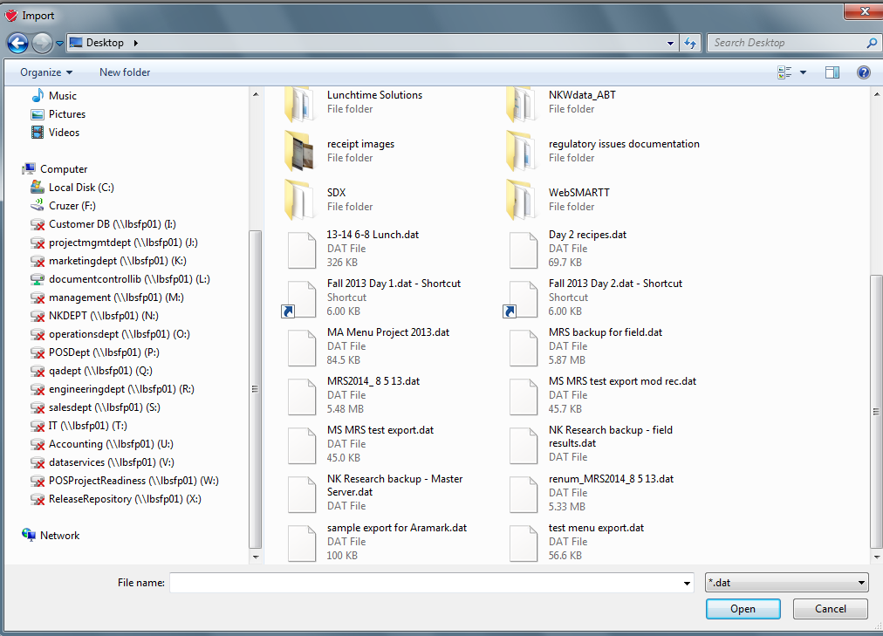

- Click on the file name containing the NUTRIKIDS data
- Click OPEN or just DOUBLE CLICK on the file.

- You will now see a window that says Import Menu Planning.
- Select the menu name that you want to import your menus into by clicking on the down arrow next to the menu name window.
- Select the month by using the UP DOWN arrows to the right of the calendar screen.
- Click and hold on a day on the right hand side of the screen and drag it over to the calendar. Drop it on the day you want it to import into.
- Repeat this step until you have placed all of the menu days on the calendar.
- Click on IMPORT.

